31st March 2016

YOKOHAMA’s New Highway Joint, YHT-N, Selected for Use on Tokyo Shuto Expressway

Tokyo – The Yokohama Rubber Co. Ltd. announced today that its new YHT-N highway joint for use in elevated highway and bridge extensions was selected in January for use in joint replacement on the Tokyo Shuto Expressway’s No. 1 Haneda route. The installation of the replacement joints was recently completed. The successful installation of the YHT-N joints paves the way for Yokohama Rubber to target adoption of its highway joints for use in the large-scale renovation of superannuated elevated sections on other routes of the Shuto Expressway. The Company also plans to expand sales of its highway and bridge extension products by capturing an expected increase in demand related to the repair and renovation of elevated roads and bridges providing access to 2020 Tokyo Olympics venues.

The YHT-N joints were introduced in January 2015 as the latest version of the Company’s YHT series of highway joints. The YHT-N incorporates an improved water-sealing rubber that improves the joint’s water-sealing quality and enhances its durability. It also features a compact structure that makes it applicable to a wide range of repair and replacement needs. The YHT-N joints were selected for use after certification by the Metropolitan Expressway Co., Ltd., following passage of noise and vibration testing, which was conducted at YOKOHAMA’s D-PARC tyre test course.

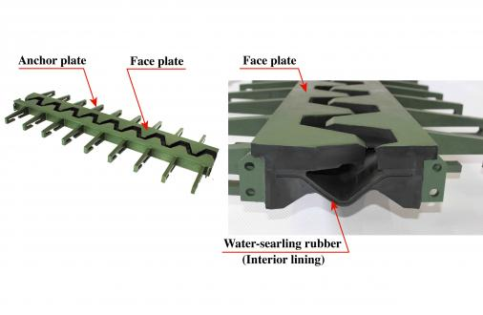 | 
Structural view of YHT-N joint | Tokyo Shuto Expressway’s No. 1 route

